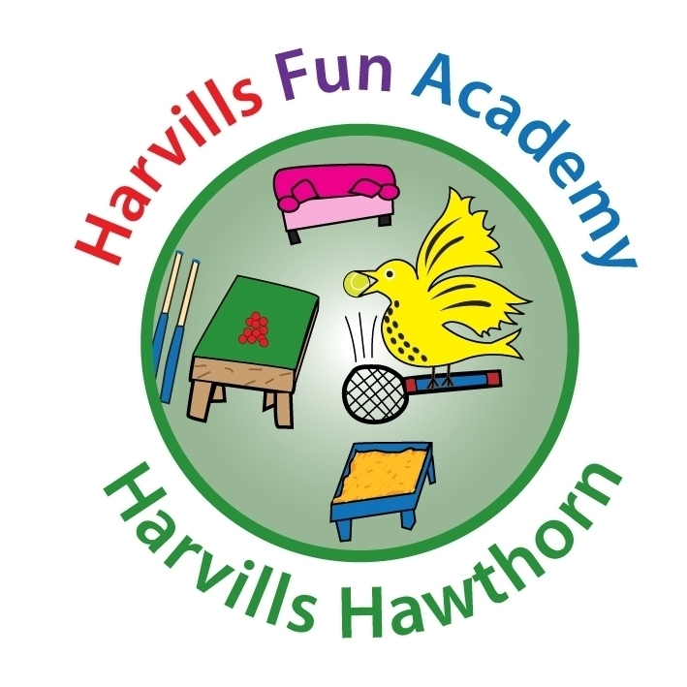
Name of child: ___________________________

HARVILLS FUN ACADEMY
PARENT AGREEMENT

Price & Time Guide

- Breakfast session (between 7:45am and the start of school) - £3.50 per session
- After-school session (from the end of school until 6pm prompt) - £6.00 per session
- Late fees £1 per minute after 6:00pm. E.g. collection at 6:15pm would incur an additional £15 charge. If your child is late being collected on three occasions during a half term, the service will be withdrawn.

Fees for Fun Academy must be paid for in advance of the sessions required. If fees are not paid on time, the service will not be available.

I am aware that, if I am late collecting my child 3 times in one half term, the service will be withdrawn.

I am aware of the above prices and know that the fees have to be paid in full before my child visits Harvills Fun Academy. I am aware that failure to do so will result in the service being unavailable.

Signed __________________________________

Booking Sessions at Harvills Fun Academy

- Sessions have to be booked in advance using Schoolgateway.
- Breakfast sessions can be booked up until 7:30am on the day of the session.
- After-school sessions can be booked up until 3pm on the day of the session
I am aware sessions must be booked on Schoolgateway.

I am aware of the times by which sessions need to be booked.

Signed __________________________________

Contact Details & Medical Needs

Contact Details and Medical Needs
- Any changes to contact details and medical needs must be passed to Harvills Fun Academy staff as well as the school office staff.
I am aware that any changes to my child's contact details and medical needs must be passed to Harvills Fun Academy staff as well as the school office staff.

Signed __________________________________

Safeguarding Procedures

- Parents/carers must approach a member of Harvills Fun Academy staff so that their child can be signed in/out electronically.
- Only parents/carers who are listed as approved contacts will be allowed to collect children.
- If, due to circumstances out of your control, you are unable to collect your child, you must contact the school on 0121 557 1034. You will need to state which adult will be collecting your child.
- Parents/carers who are not contactable for whatever reason will be referred to Children’s Services and future service from Harvills Fun Academy will be withdrawn.
- All policies will be available on request from Harvills Fun Academy.
I am aware that failure to comply with any of the above safeguarding procedures will result in my child's place at Harvills Fun Academy being withdrawn.

Signed __________________________________

FOR HARVILLS FUN ACADEMY USE ONLY:

Received by: __________________________ Signature:_________________________

Date: __________________________

